PROJECT ON STUDYING AND ANALYZING CAR PARKING
STUDENT NAME:
INSTITUTION:
DATE:

Deliverable 1
- Problem definition
Car parking sheds are very important for prolonged service life of the car while still maintain good shape and condition (Royal tensile structure PVT.ltd, n.d. The various designs of car parking such as tensile structure, tensile rooking, conical tensile roofing and conical tensile structure or shape (The shade studio, n.d). The materials used to design these car parking sheds determines how best and how long they will offer conducive parking services to the car. Some of the car parking sheds end up being disastrous to the car rather than being beneficial. The car parking sheds are to provide protection against weather, including solar radiation, ultraviolet rays, rain, wind and dust. They should also give safety and security to the car and addition to fuel saving (The shade studio, n.d). But what happens when the car parking shed has been design with poor material which is not robust enough to give the car the necessary protection? It is common to find some parking sheds collapsing and when they collapse, the end results are costly damages to the car such as deformation of the car roofing and wind screen breakages. This project aims at studying and analyzing the materials generally used for car parking shed construction and propose the best material for use (Steel Construction. info, n.d).
- Car parking dimensions
The car parking under study is of tensile structure type. The structures are made of steel metal while the roofing has been done using the High Density Poly Ethylene (HDPE) mesh fabric. The length of the car parking is 6m, width 3m and height is 3m.
- AutoCAD drawing for the car parking
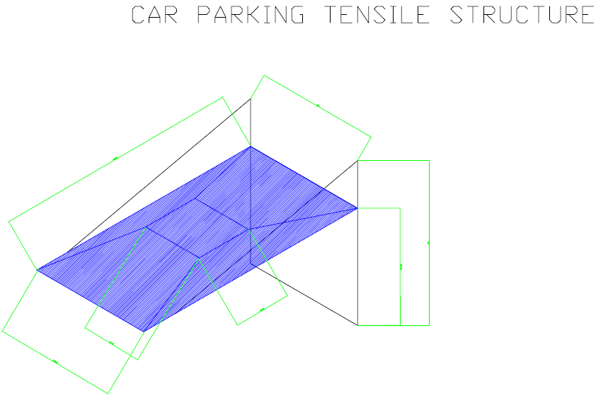
- Potential materials used in making car parking frames
The most common materials used for making car parking frames are mild steel and wood (Allen and Iano, 2019). As they are readily available and also relatively cheap compared to the rest such the alumawood, aluminum and concrete. Alumawood is typically aluminum which has been made to look like wood (Architecture lab, 2018). It has good aesthetic value compared to steel. It is also found in different colors. Some frames are made of aluminum which relatively light compared to both steel but is just durable like steel. Reinforced concrete which consists of steel metal can also be used to make the car parking structures (Architecture lab, 2018).
The three different materials which are suitable for making the car parking structures are, wood, steel and reinforced concrete.
- Workplan
For the study to be complete, there is need of constructing a car parking frame using the five materials mention above, steel, wood, alumawood, aluminum and reinforced concrete, in the same environmental condition then carrying our possible failure analysis in each.

References
ALLEN, E. & IANO, J. 2019. Fundamentals of building construction: materials and methods, John Wiley & Sons.
Architecture lab. (2018). What is a Carport: Sheds Defined, Structure Types, Advantages and Disadvantages. Retrieved from: https://www.architecturelab.net/what-is-a-carport/
Royal Tensile Structure PVT.LTD. (n.d). Tensile Car Parking: Tensile Car parking Delhi. Retrieved from https://royaltensilestructure.com/tensile_car_parking.html
Steel Construction. Info. (n.d). Attributes of good car park design. Retrieved from: https://www.steelconstruction.info/Car_parks
The Shade Studio. (n.d). Benefits of Car Parking Sheds. Retrieved from http://www.theshadestudio.co.in/benefits-of-car-parking-sheds

